Underground Hero

Software Requirements Specification

*CxTemp_SoftwareRequirementsSpecification.doc*

**Draft 1**

*September 6, 2016*

**Justice League Group**



**Revisions**

|  |  |  |  |
| --- | --- | --- | --- |
| **Version** | **Primary Author(s)** | **Description of Version** | **Date Completed** |
| Version 1.0 | Peter Adeojo  Cristian Cardona  Kevin Stevens  Josh | Information about the revision. This table does not need to be filled in whenever a document is touched, only when the version is being upgraded.  *CxPattern_RevisionHistory* provides details on CxOne’s recommended way to handle document revisions. | 00/00/00 |

**Contents**

**1 Introduction**

1.1 Purpose

1.2 Scope

1.3 Definitions, Acronyms, and Abbreviations

1.4 References

1.5 Overview

**2 Overall Description**

2.1 Product Perspective

2.2 Product Functions

2.3 User Characteristics

2.4 Constraints

2.5 Assumptions and Dependencies

2.6 Apportioning of Requirements

**3 Specific Requirements**

3.1 overall game description

*3.1.1 Rooms*

*3.1.2 Enemies*

*3.1.3 Puzzles*

*3.1.4 User Interface Interfaces*

3.2 Software Product Features

*3.2.1 Feature 1*

Purpose

Stimulus/Response Sequence

Associated Functional Requirements

3.3 Performance Requirements

3.4 Design Constraints

3.5 Software System Attributes

*3.5.1 Reliability*

*3.5.2 Availability*

*3.5.3 Security*

*3.5.4 Maintainability*

3.6 Logical Database Requirements

3.7 Other Requirements

# Introduction

## Purpose - Cristian

This document is meant to be used as a set of instructions and/or guidelines to create a text based game which consists of at least 32+ rooms, 8+ puzzles, 8+ monsters. This document is intended for a group which will create the game for us based on our requirements.

## Scope - Cristian

* It will be a text based adventure game. All actions will be done by typing commands into a text field. Any menus will be created using ASCII art.
* The player will travel around the underground lair of a supervillain
* Monsters and puzzles will be encountered throughout the game in a given order.
* Each room will have at least one entrance and exit, once the room has been entered it will remain open, meaning the player can go back to it.
* Once defeating the final boss, the player will be done with the game.

## Definitions, Acronyms, and Abbreviations

Player: The character that the user is playing as.

Enemy: An antagonist that the player must defeat to progress.

HP: Health Points, or the character’s vitality; ones this reaches zero for a character, that character dies.

ATK: Attack points. This measures how much damage a character can do.

DEF: Defense points. This measures how much damage a character can negate when attacked.

SDP: Speed points, determines how fast the entity will move; their order in battle.

Takes damage: The character’s HP is reduced by this amount.

## References

We have no references.

## Overview - Kevin

The remainder of this document includes two chapters and appendixes. The second one provides and overview of the product’s perspective and functions, user characteristics, constraints, assumptions and dependencies, and apportioning of requirements.

The third chapter provides the requirements specification in detailed terms, including descriptions of every room, monsters, and puzzles in the game.

## Product Perspective - PAdeojo

This product is self contained as it will not interact with other systems on the computer. This product will, once installed, act as a singular isolated entity on the computer. That is to say it will not attempt to touch or access any functions that other programs might attempt to use, which include but are not limited to:

* The Camera
* The Microphone
* The Internet
* The Graphic Display
* The Graphics Shader
* Operating System or System Utilities

## Product Functions - PAdeojo

This software will be an interactive text based adventure game. The game is entirely text based with no music or sound, and the only pictures will be those made out of ASCII art. The games environment will be fueled by the customers imagination, helped along with detailed descriptions of their surroundings.

## User Characteristics - Kevin

The user will be anybody who can read English at at least a fifth grade reading level. They will interact with the game by typing commands into a text entry box.

## Constraints - Josh

The system shall be tested for memory leaks and will contain none upon its initial release. The system shall be written in a language that can be run on multiple operating systems, or one that is easily portable to operating systems other than the original; in the case of the latter, all versions of the game shall be delivered on the initial release. With the exception of writing to and reading from a save file, the system will not have any interaction with any other systems on the user’s computer.

## Assumptions and Dependencies - Josh

It will be assumed that the user has a basic understanding of interacting with computers. It will also be assumed that the program will at all times have sufficient system resources to run.

## Apportioning of Requirements - Josh

In the event that time constraints will prevent implementation of all game features, these features may be delayed until subsequent release:

* In game map
* Multi user support
* Scoring system tied to an in-game clock

# Specific Requirements

## Overall Game Description- Josh/Kevin

In the game you are a Batman-esque superhero who has no superpowers, but is clever and a good fighter. He has infiltrated a super villain's underground lair with the hope of stopping the detonation of an apocalyptic doomsday device. Along the way he will pick up items and gadgets to help him reach the supervillain on the bottom floor and stop his evil scheme.

### Rooms

#### Floor 1 - Cristian

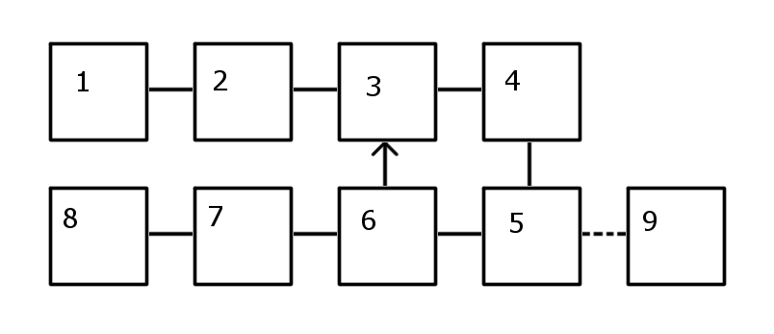

**Room 1-1**

* The player will enter this room after a brief introduction / backstory that gets the game going.
* An exit to the West will place the player outside the building and lead to a secret ending where the hero just leaves, and moving to the East will allow the player to enter room 1-2.
* This is the first room in the game, upon entering the room, the player sees that it is an office type of room, the light is dimmed to a level that it is still easy to see. There is a “front desk” to the left with a tall artificial plan and a brown leather couch across to the right. There is no trace of people in the office space. The front desk has a monitor that seems to be on, also there is a steamy coffee on the desk. Some papers scattered around the desk along with some pens. A painting of a red boat on the sea hangs above the couch, and a poster next to the front desk which says: “Which are you: A B O AB?”. The door to the next room past the couch and the desk about the middle of the two.

**Room 1-2**

* Connects to the west wil room 1-1
* Connects to the east with room 1-3
* The second room is an office supply storage room with two big printers to the left as soon as one enters the room. Along the north wall, there are some shelves with paper, and some cabinets which are locked. Some computer equipment is there like routers and modems along with some important reminders and a contact list to people the player does not know anything about.

**Room 1-3**

* Connects to the west with room 1-2
* Connects to the east with room 1-4
* The third room is a meeting room which has a white board on the corner and several chairs and two couches. There is a window on the north wall which has the blinds down. The board has some target numbers written on it.
* There is a red couch, with a man sleeping on it, he is very slender with tattoos everywhere, wearing a white shirt, black pants and some boots. He looks at the player upon entering and say “hi” in a very calmed way.

**Room 1-4**

* Connects west with room 1-3.
* Connects south with room 1-5
* This room has several shelves with neatly stacked clothes on it, alongside the shelves, there is a counter with a sink and a coffee maker. A cabinet above the coffee maker.

**Room 1-5**

* Connects north with room 1-4
* Connects west with room 1-6.
* Connects east with room 1-9, which is not told to the player as it is a hidden room.
* This room has a desk which looks fancy and it is located on the southeast corner of the room. It is made from dark brown wood and it has a library next to it extending all the way to the north wall and covering the entire north wall. The shelves go from the ceiling to the ground and are filled with books of all kinds, also the shelves have decorations on them, like some wooden figures that resemble African heritage, also an hourglass (sand clock) which by the way has been turned upside down with the time ticking. There’s world map behind the desk covering most of the south wall. There is one painting next to the door which leads to room 1-6, the painting is of a lady.

**Room 1-6**

* Connects east with room 1-5
* Connects west with room 1-7
* Connects north with room 1-3
* This room consists of a closet and shower like room, it all white and very clean, the floor is white, the light is white, everything is white, except there is bloody handprints everywhere on the northwestern corner of the room, there’s a thick trail of blood going into the room westward. This room also connects to the room 1-3. Keep in mind the doors are thick and not much sound gets through to the other side.

**Room 1-7**

* Connects west with room 1-6
* Connects east with room 1-8
* This room consists of a steel bed, it has a body on top of it. It is inside a body bag, it’s very cold in this room, doesn’t smell like anything. The body could be just a dummy. Same as the previous to this one, everything is white, the lights are dimmed, and somewhat flickery. There are some sharp tools on a tray.

**Room 1-8**

* Connects east with room 1-7
* Stairs on the west side lead to floor number 2, after Blood Sucker, Puzzler and their puzzles have been defeated.
* After Puzzler is defeated, the player may search him to find Steroids.
* There’s a man sitting there on a chair, the Puzzler. Wearing a purple shirt and holding a cane. He is smoking something which filled up the room with smoke. His name is Puzzler, the boss of floor one, he seems to have had a bad day, so who knows what he could do.

**Room 1-9 (OPTIONAL ROOM)**

* Connects west with room 1-5
* Contains the Diamond Tipped Cutter
* Secret room to the west side of room 1-5. This room has weapons and health the player can pick up. There is a lock to the door once inside it and it works as a safe place in case it is needed. The room has a purple light bulb which makes the room appear very purple.

#### Floor 2 - Kevin

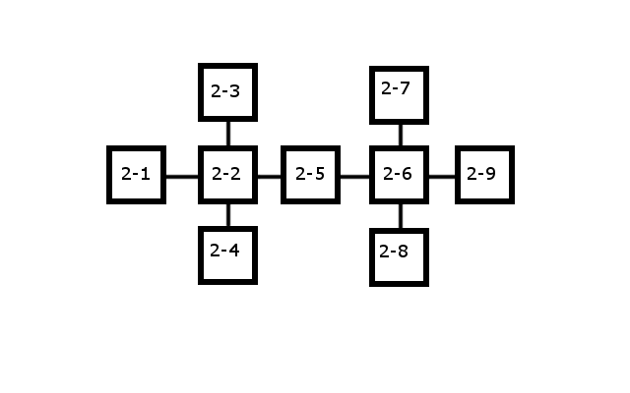

**Room 2-1**

* The player starts the floor in this room
* An exit to the East leading to room 2-2

**Room 2-2**

* An exit to the West leading to room 2-1
* An exit to the North leading to room 2-3
* An exit to the South leading to room 2-4
* An exit to the East leading to room 2-5
* An adrenaline shot on the ground
* Chance at a random encounter with Hula Hooper

**Room 2-3**

* An exit to the South leading to room 2-2
* Four statues on the North wall: a Duck, a Giraffe, an Elephant, and a Cow. Their order is randomized (but cannot be randomized to the puzzle’s solution), and they can be moved
* A pedestal in the center of the room holding a pair of red boots that are protected by an energy force field
* Chance at a random encounter with Hula Hooper

**Room 2-4**

* An exit to the North leading to room 2-2
* Four statues on the South wall; from East to West, a Duck, a Giraffe, an Elephant, and a Cow
* An empty pedestal in the center of the room
* Chance at a random encounter with Hula Hooper

**Room 2-5**

* An exit to the West leading to room 2-2
* An exit to the East leading to room 2-6
* A hallway that shoots lasers at anyone who tries to pass; if the player tries to exit through the East door without the Speed Boots, they are unable to and take 1 HP of damage
* Chance at a random encounter with Hula Hooper

**Room 2-6**

* An exit to the West leading to room 2-5
* An exit to the North leading to room 2-7
* An exit to the South leading to room 2-8
* An exit to the East leading to room 2-9; this exit is locked
* Chance at a random encounter with Hula Hooper

**Room 2-7**

* An exit to the South leading to room 2-6
* Chain mail on the ground
* A monitor on a desk that displays the following:
  + The numbers “255, 0, 255” in magenta
  + The numbers “0, 255, 255” in cyan
  + The numbers “255, 255, 0” in yellow
  + The numbers “2, 1, 3” in white
* Chance at a random encounter with Hula Hooper

**Room 2-8**

* An exit to the North leading to room 2-6
* An adrenaline shot on the ground
* A key on a pedestal being protected by a force field
* A panel in front of the force field with three buttons on it: one red, one blue, one green
* Chance at a random encounter with Hula Hooper

**Room 2-9**

* An exit to the West leading to room 2-6
* No chance to encounter Hula Hooper
* The Floor 2 Boss: Pogo
* After Pogo is defeated, the player may search him to find Steroids.
* The entrance to Floor 3, accessible once Pogo is defeated

#### Floor 3 - Josh

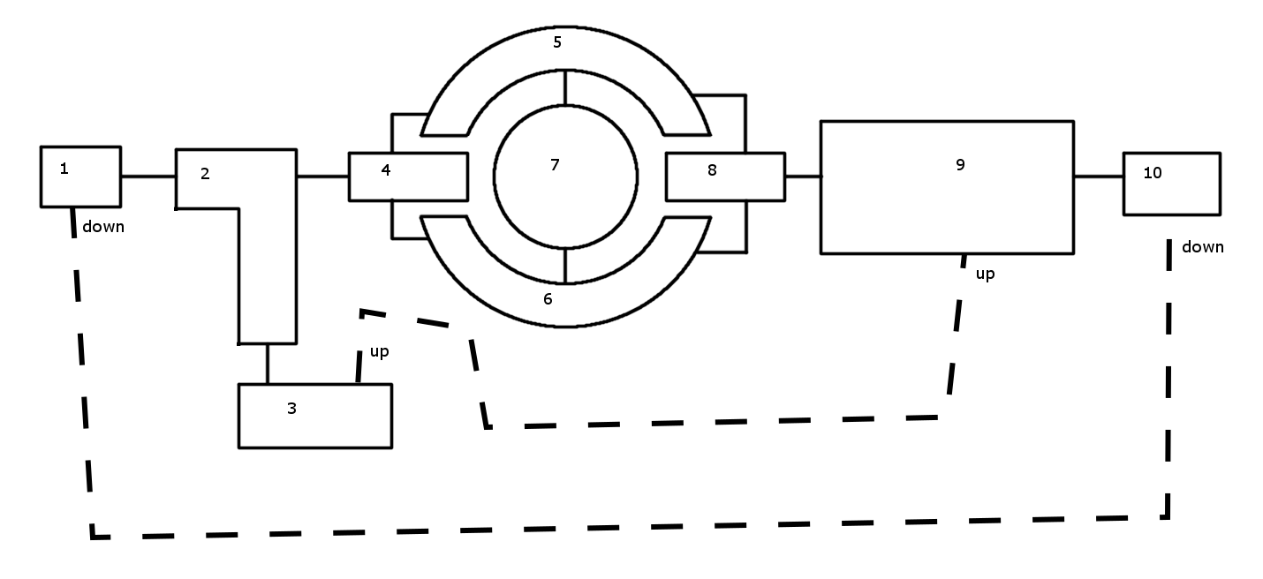

Unless otherwise noted, this floor is rather well lit. It’s not bright, but there aren’t many shadows either. Think of a room that gets a lot of natural light around 2pm. Rooms with no or minimal decoration described may be “spiced up” by the implementing team if they feel that such changes would create a better user experience. We leave this point to their discretion.

**Room 3-1**

* The player starts the floor in this room
* An exit to the West leading to room 2-9
* An exit to the East leading to room 3-2
* A hidden shortcut through a crawl space below leading to room 3-10, accessable only once the player has completed the Security Bypass puzzle
* A square room with steel plating covering all surfaces. The only objects here are the doors leading to the East and West (and the hidden crawl space).

**Room 3-2**

* An inverted ‘L’ shaped room
* An exit to the West leading to room 3-1
* An exit to the East leading to room 3-4
* An exit to the South leading to room 3-3
* This room is also covered in steel plating. One of the overhead lights flickers at a frequency that doesn’t actually diminish the amount of light in the room, it just causes an annoyance. The only objects are the doors to the East, South, and West.

**Room 3-3**

* The security room
* Contains the security terminal for the completion of the security bypass puzzle
* An exit to the North to room 3-2
* A hidden shortcut through the ventilation system above leading to room 3-8
* A rectangular room filled with monitors and cabling; a rack of computers sits at the end. The lighting is dimmer than normal and as a slight blueish hue. The electronics put out a lot of heat, so while this room is lined with steel plating like the rooms before it, it has a large exposed ventilation system in the ceiling. There is a case made of ballistic glass on the far wall which contains the Prototype Laser Pistol.

**Room 3-4**

* A hallway that splits into a fork at the end.
* An exit to the West leading to room 3-2
* An exit to the North leading to room 3-5
* An exit to the South leading to room 3-6
* A slightly rectangular room with a fork at the eastern end. The room’s ceiling grows higher and wider as the room approaches the fork, and the rooms construction transitions from steel plating to exposed cave wall reinforced in places by rebar and I-beams. During this transition the lighting changes from overhead to standing work lights. Toward the fork side of the room, stalactites have begun to form.

**Room 3-5**

* A semicircular room
* An exit to the West to room 3-4
* An exit to the East to room 3-8
* An exit to the South to room 3-7
* A moderately wide, short ledge that is semicircular in shape surrounding an underground lake’s northern edge. The room has high ceilings that curve upwards toward the center of the lake (located in room 3-7). The ceiling is covered by medium-large stalactites. The room has exposed cave wall reinforced in places by rebar and I-beams. The room is lit from the ground by upward firing lights angled toward the wall. Room 3-7 is visible from this location, and room 3-6 can be made out.

**Room 3-6**

* A semicircular room
* An exit to the West to room 3-4
* An exit to the East to room 3-8
* An exit to the North to room 3-7
* A moderately wide, short ledge that is semicircular in shape surrounding an underground lake’s southern edge. The room has high ceilings that curve upwards toward the center of the lake (located in room 3-7). The ceiling is covered by medium-large stalactites. The room has exposed cave wall reinforced in places by rebar and I-beams. The room is lit from the ground by upward firing lights angled toward the wall. Room 3-7 is visible from this location, and room 3-5 can be made out.

**Room 3-7**

* A deep underground lake
* The grappling hook is collected from this room
* The Giant Bull Shark live in this room
* An exit to the North leading to room 3-5
* An exit to the South leading to room 3-6
* The lake is both located deep underground and is deep itself. The water is incredibly clear and clean, and yet very deep in color as well. In what is more or less the center of the lake is an underwater plateau with the grappling hook on it; the plateau is close enough to the surface that the grappling hook is visible from rooms 3-5 and 3-6. Stalactites cover the ceiling and reflect light from rooms 3-5 and 3-6 into this room.

**Room 3-8**

* A long hallway that splits into a fork at the end.
* An exit to the North leading to room 3-5
* An exit to the South leading to room 3-6
* A hidden shortcut through the ventilation system above leading to room 3-3
* A rectangular room with a fork at the western end. The room’s ceiling lowers as the room moves away from the fork. The room has exposed cave wall reinforced in places by rebar and I-beams. The room is lit from the ground by upward firing lights angled toward the wall. There is a ventilation duct in the lower part of the ceiling partially obscured by small-medium sized stalactites. There is no door separating this room from room 3-9, it simply continues into the next.

**Room 3-9**

* A large rectangular room with a deep chasm in the middle of it
* An exit to the West leading to room 3-8
* An Exit to the East leading to room 3-10, the grappling hook must be used to access this exit
* A massive rectangular room with a wide chasm offset to the eastern side of it. Due to the room’s sheer size, the lighting isn't quite adequate and so the room is a good bit darker than the other rooms on this floor. Apart from the lighting and the door at the eastern end leading to room 3-10, this room is void of any manmade objects. Stalactites of various sizes line the ceiling and stalagmites the floor. There is a stronger outcropping of rock above the chasm that the grappling hook can attach to. Though barely visible, there are steel spikes at the bottom of the chasm.

**Room 3-10**

* The floor 3 boss: Giant Robotic Sentry
* An exit to the West leading to room 3-9
* After the Giant Robotic Sentry is defeated, the player may search it to find Steroids
* An exit to the East leading to room 4-1, accessible only once the giant robotic sentry has been defeated
* A hidden shortcut through a crawl space below leading to room 3-1, accessible only once the player has completed the Security Bypass puzzle
* A small square room with high ceilings and a large, locked steel blast door on the eastern wall of the room; in front of the door stands the Giant Robotic Sentry This room is well lit with both the floor lighting as described in rooms previous, and overhead lighting. A hidden crawl space is revealed and the blast door unlocked once the player has completed the Security Bypass puzzle.

#### Floor 4 - PAdeojo

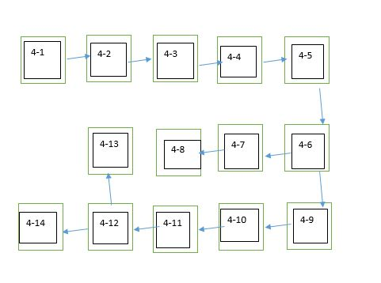

**\*Each room should have a 45% chance of having a random encounter with the hyena.**

**Room 4-1**

* The room in which the player starts the level
* Exit to the east
* A large octagon room with one exit to the east. The room is colored in a dark blue light with statues of lions adorned at the corner of each of the eight corners of the room. The floor a slick black concrete with a but dead in the center is a sloppily trail of green arrows leading to the door.

**Room 4-2**

* Exit to the east
* The room is dimmed and is a straight hallway. With one door on the east side.

**Room 4-3**

* A dark room with eyes drawn all over the walls, in the center of the room leading towards the exit is a picture of a brain.
* Exit to the east
* A Bright green light shines directly into the room directly at he only door. Around it is a very sinisterly written “HaHA” scrawled over the pictures on the wall.

**Room 4-4**

* Exit to the east
* This room is lit in a bright green light with the single door to the east. The recurring pattern of a brain is still scrawled along the wall. The door is old and very decrepit looking.

**Room 4-5**

* Exit to the south- Cannot Exit until Riddle is solved
* I have billions of eyes, yet I live in darkness. I have millions of ears, yet only four lobes. I have no muscle, yet I rule two hemispheres. What am I?
* Answer: Brain
* The room is a large box with a majestic door to the south. A voice box over your head continues to play a riddle in a loop “ I have billions of eyes, yet I live in darkness. I have millions of ears, yet only four lobes. I have no muscle, yet I rule two hemispheres. What am I?” The room is a majestic as the door with the sides being decorated with intricately designed patterns.

**Room 4-6**

* The room continues to follow its majestically made pattern but it begins to look more sadistics. The paintings on the wall all despite it ornate frames hold pictures of clowns who are either screaming, crying, or looking sinisterly angry
* Exit to the West
* Exit to the South

**Room 4-7**

* This room contained all the costumes generally worn during the circuses. There in the corner sits a clown reading a newspaper who after briefly noticing you shrugs and goes back to reading his paper. Notably the paper titled “The Clown Times” headline is on the rising price of clown college.
* Exit to the West

**Room 4-8**

* This room seems to contain the animals of the circus, however it does not seem that anyone has attempted to cage them. Lions, elephants, monkeys, and more roam the open room. The lions have made their stake in the corner of the room and have amassed a large body count that has become their dinner.
* Exit to the West

**Room 4-9**

* This room is boldly titled the Hall of Mirrors at the very top, and much as the name suggest, the room is filled with mirrors. Mirrors that make you long, mirrors that make you short, there was a just about every type of mirror in this room.
* Exit to the West

**Room 4-10**

* This room contains a wide variety of small cars. Despite being clown cars many of these cars were very expensive looking. A wide variety of clown car muscle cars filled the room.
* Exit to the West

**Room 4-11**

* The room is dark and narrow leading to the only door to the western section of the wall.
* Exit to the West

**Room 4-12**

* This leads to torch lit room where in the center is blazing ring of fire. There is one exit on the westward wall and by it, a golden statue of a tiger. The wall has been turned into a mural of people jumping through flaming objects.
* Exit to the West
* Exit to the North- Cannot go North until they solve the riddle
* What belongs to you, but is used by others?
* Enemy Quinn Har
* *Their name, or “your name” should be acceptable answers

**Room 4-13**

* The last room is a decrepit movie theater. There are no seats and the floor boards are all but destroyed. In the center of the the room is a curtain lavishly colored in the orange and red colors often seen at carnivals. Between the screens is a blank projector screen and there sitting in the center is the evil clown Joe Ker laughing maniacally.
* Enemy Joe Ker
* Exit to the West

### Monsters

Stat scale:

HP: 30pt

ATK, DEF: 15pt

SPD: 3pt

**Floor 1 - Cristian**

ENEMY NAME: Blood Sucker

DESCRIPTION: A man with a metal straw and awkwardly fast moves.

STATS:

* HP: 2
* ATTACK: 2
* DEFENSE: 0
* SPEED: 3

ACTIONS:

* ATTACK: 40%
* DEFENSE: 0%
* Blood Sucking: 60%
* Blood sucker is an attractive tall man, with a strong jaw line, long black hair and a deadly stare. He’s not much for games, his puzzles are simple and even dumb. He is witty and will attack for as little as not agreeing with him.

ENEMY NAME: Puzzler

DESCRIPTION: A man with a purple suit and question marks all over this suit, a hat and cane.

STATS:

* HP: 4
* ATTACK: 4
* DEFENSE: 4
* SPEED: 1

ACTIONS:

* ATTACK: 50%
* DEFENSE: 50%
* He tricks people with his riddles as well as his spontaneous attacks and break-outs of laughter
* Puzzler has a cane which he uses as a weapon or tool to distract his opponents.

**Floor 2 - Kevin**

ENEMY NAME: Hula Hooper

DESCRIPTION: A man using a hula hoop. There are knives strapped to the hula hoop to make it deadly.

STATS:

* HP: 6
* ATTACK: 3
* DEFENSE: 0
* SPEED: 1

ACTIONS:

* ATTACK: 40%
* DEFEND: 30%
* HULA HOOPING: 30%
  + He does nothing, just stands there hula hooping

ENEMY NAME: Pogo

DESCRIPTION: A man on a pogo stick. The pogo stick has machine guns attached to it.

STATS:

* HP: 12
* ATTACK: 6
* DEFENSE: 1
* SPEED: 3

ACTIONS:

* ATTACK: 50%
* DEFEND: 20%
* BOUNCING AROUND: 20%
  + He does nothing, just bounces around on his pogo stick
* FIRES WILDLY: 10%
  + He fires his gun randomly around the room. This has a 50% chance of hitting the player and dealing 7 damage minus the player’s Defense.

**Floor 3 - Josh**

ENEMY NAME: Giant Bull Shark

DESCRIPTION: What every good super villain needs; a giant bull shark that lives in the lake that their underground lair obviously has. His name is Snappy.

STATS:

* HP: 12
* ATTACK: 7
* DEFENSE: 0
* SPEED: 3

ACTIONS:

* ATTACK: 80%
* DEFEND: 0%
* SNEAK ATTACK: 0%
  + Initial attack upon encounter, deals 12 damage before defensive calculations.
* CHARGE ATTACK: 20%
  + The shark runs away for a turn, making him unattackable. When he returns he rams into the player dealing 10 damage before defensive calculations.

ENEMY NAME: Giant Robotic Sentry

DESCRIPTION: A giant robotic sentry guarding the entrance to the final floor. The sentry is a slow moving bipedal robot with lots of armor plating (looks something like a cross between Ultron and the Destroyer from Thor, but talle r and with a thinner torso). The sentry is armed with a gatling laser, sonic emitters, and a blade that is stored in his forearm when not in use.

STATS:

* HP: 15
* ATTACK: 4
* DEFENSE: 5
* SPEED: 1

ACTIONS:

* ATTACK: 40%
* DEFEND: 30%
* STUN: 10%
  + The sentry fires his sonic emitters, stunning the player for one turn. While stunned the player can take no actions.
* IMPALE: 5%
  + The sentry impales the player with his blade, lifts the player over his head, inverts his blade and slams the player to the ground. The sentry’s blade shatters on impact making this ability usable only once. The sentry spends one turn walking up to the player and impales them on the next turn. Attack deals 15 damage before defensive calculations.
* HEAL: 15%
  + The sentry spends a turn healing by way of nanobots. This ability will regenerate 3 HP

**Floor 4 - PAdeojo**

ENEMY NAME: Joe Ker

DESCRIPTION: A Deranged clown with a thirst for destruction and chaos. While he is not strong, he is quick and smart.

STATS:

HP:30

Attack: 7

Defense:8

Speed: 3

ACTIONS:

-Cut: 40%

Joe attempts to slice the player with a knife. This attack is usable multiple times and will be Joe’s Main form of attack

-Hit With Crowbar: 40%

Joe will attempt to beat the player senseless with a crowbar. This should inflict 2 separate hits meaning if the attack lands it is as if you are hit twice by the same attack. The attack will deal about 5-13 damage before defensive calculations

-Toxic Gas: 20%

Joe will attempt to poison the character. If the hit lands, this will cause 1-3 points for 5 turns of damage per turn. Due to the limited quantity of the gas Joe can only use it twice. However the damage does not stack, only the turns do. Meaning if hit twice, the player can receive up to 10 turns of this damage.

Dodge

Joe will attempt to dodge the opponents attack.

ENEMY NAME: Quinn Har

DESCRIPTION: A female clown with a red and black color scheme. She uses a large mallet

STATS

HP:30

Attack: 9

Defense: 4

Speed: 2

ACTIONS:

Hammer Smash: 20%

Quinn will attempt to slam her hammer into her opponent. This has a base amount of damage of 10 before any defensive addons.

Round House Kick:40 %

Quinn will attempt to roundhouse kick you. This has a base damage of 4 before any defensive addons.

Tackle:39%

Quinn will attempt tackle the opponent. This will give out 1-3 points of damage before any defensive modifications

Dodge: 1%

Quinn will attempt to dodge an attack

ENEMY NAME: Wild Hyena

DESCRIPTION: A starving wild hyena that lives in the dark corners of that underground lair. It’ll eating anything, including you.

STATS:

* HP: 12
* ATTACK: 7
* DEFENSE: 0
* SPEED: 3

ACTIONS:

* ATTACK: 80%
* DEFEND: 0%
* SNEAK ATTACK: 0%
  + Initial attack upon encounter, deals 12 damage before defensive calculations.
* CHARGE ATTACK: 20%
  + The hyena runs away for a turn, making him unattackable. When he returns he rams into the player dealing 10 damage before defensive calculations.

### 

### Puzzles

#### Floor 1 - Cristian

**Enemy info**: Blood sucker is a sucker for math and science, for whatever reason he has used his immortality to study and understand the world better.

The Puzzler is a smart guy that likes to play with people’s minds and talk in funny ways, but don’t disregard him as he can very well attack using his cane.

**Puzzle name**: A blood type.

**Setup**: List two blood types. (A, B, AB, O).

**Solution**: The player will enter a combination of two out of the four possible blood types.

**Reward**: Defeat Blood Sucker.

**Puzzle name**: Painting.

**Setup**: The player walks into room 1-9, the player feels like he/she is being watched, this room has many fancy objects all around it, but one stands out the most, a painting, the painting is looking straight at you, giving you a chill down your spine, the painting is very famous. The player thinks to himself what is the name of painting that is watching me? //(**mona lisa**)

**Reward**: power increase which will help to defeat the Puzzler.

#### 

#### Floor 2 - Kevin

PUZZLE NAME: The Animal Statues

SETUP: There are four animal statues in rooms 2-3 and 2-4. In 2-4, they are on the South wall and cannot be moved and are, in order from East to West (which will appear to be left to right to the player): Duck, Giraffe, Elephant, Cow. In room 2-3, they are on the North wall, the order is randomized (but cannot be randomized to the puzzle’s solution), and can be moved.

SOLUTION: The statues in 2-3 must be rearranged to match the order of the statues in 2-4, from East to West. However, this order will appear reversed to the player because they are facing the opposite direction.

REWARD: The energy force field on the pedestal powers down, and the player can pick up the Speed Boots.

PUZZLE NAME: The Laser Hallway

SETUP: There is a hallway that shoots lasers at anyone who tries to pass in room 2-5. If the player tries to pass without the Speed Boots, then they are unable to and take 1 HP of damage.

SOLUTION: If the player has the Speed Boots, then they are able to dodge the lasers and run through the room to make it to the other exit.

REWARD: The player is able to move on to room 2-6.

PUZZLE NAME: The Colored Buttons

SETUP: In room 2-7 is a monitor with several groups of numbers, each group a different color. The final group of numbers is “2, 1, 3” in black. In room 2-8 are three buttons, red, green, and blue.

SOLUTION: The player is supposed to determine that the numbers in room 2-7 are RGB values. Thus, the last group of numbers is saying Red 2, Green 1, Blue 3. This is the order you must press the buttons in to get the key.

REWARD: A key that lets the player open the door to 2-9 and fight the boss of the floor.

#### Floor 3 - Josh

PUZZLE NAME: Jump The Chasm

SETUP: You need to clear a chasm (in room 3-9) to progress further into the villain’s lair. There appears to be a strange outcropping of rock in the ceiling. If only you could attach some rope to it you could swing across, but be careful, it’s a long way down; and you think you see some spikes...

The player may attempt to jump the chasm, but doing so will result in their death. The player must input the command to jump three times before they actually jump. The first two times the game will output text along the lines of the player second guessing themself/losing their nerve at the last second.

SOLUTION: In the semicircular rooms (rooms 3-5 and 3-6) surrounding the lake (room 3-7) the player observes what appears to be a grappling hook in the center of the lake. What isn’t observed is that the giant bull shark is hiding in the depths of the lake. The player will have to enter the lake, fight and kill the shark, and then collect the grappling hook before they can progress.

REWARD: Progression to the 3rd floor boss.

PUZZLE NAME: Security Bypass

SETUP: You have just defeated the level boss, the giant robotic sentry. You are winded. You gather yourself to push on, but as you come to the door you notice that it is locked with no visible way to open it, and it appears far too thick to break through with anything less than a comically large amount of explosives, or a giant robot ― ironically. Defeated, you angrily hit the door with your fist. You turn to take out your anger on your defeated foe when you notice an odd looking computer chip protruding from the robot’s broken head. “Security Bypass” is printed on the chip. Hoping against hope you press your head against the door and hear the hum of a strong electromagnet. You take the chip and begin your search for a suitable computer terminal.

SOLUTION: Defeat the giant robotic sentry and examine him to find the computer chip. Take the chip to the computer terminal located in room 3-3 and install it. Once installed the player must “hack” into the chip to activate the bypass. The hack is completed by playing a game of Tower of Hanoi. The tower will be four units high start and in the left column, constructed correctly, it must be moved to the right column to be solved.

REWARD: Unlock the door to floor 4 and the shortcut connecting rooms 3-1 and 3-10.

#### Floor 4 - PAdeojo

Puzzle Name: Riddle 1

Setup: You walk into a room and on the wall towards the exit is a riddle to which the user must enter the answer

Solution: The Answer is “brain”

Reward they are able to pass on through the door and allows them access to 4-6

Puzzle Name: Riddle 2

Set Up: Another Door blocks your way and it needs the correct answer for you to pass through.

Solution: Their Name

Reward: Passage through to the next room which lead into the final boss fight.

### Items

ITEM NAME: Adrenaline shot

ITEM USE: Heals the user 10 HP

ITEM NAME: Steroids

ITEM USE: Increases max HP by 5, and heals fully

ITEM NAME: Diamond tipped cutter

DESCRIPTION: This item allow the player to cut through ballistic glass

LOCATION: 1-9

### Equipment

ITEM NAME: Starting clothes

DESCRIPTION: The player starts the game with this equipped

STATS: Defense: 1

LOCATION: 1-1

ITEM NAME: Starting weapon

DESCRIPTION: The player starts the game with this equipped

STATS: Attack: 3

LOCATION: 1-1

ITEM NAME: Chain Mail

DESCRIPTION: A lightweight piece of armor that is particularly good at stopping stabbing attacks.

STATS: Defense: 3

LOCATION: Room 2-7

ITEM NAME: Prototype Laser Pistol

DESCRIPTION: A sleek looking pistol, seemingly made out of titanium judging by the color. It has no visible seams or welds and fires a brilliant blue bolt of light.

STATS: Attack: 3

LOCATION: 3-3

### User Interfaces- PAdeojo

The initial user interface will be the main menu which will give them the option to open and load up a game. The game will have no buttons. It will be exclusively text based in both user input and user response. For example if a user would like to move east he will type east into the textbox and his character will move accordingly

The fighting system will be the same. In order to fight they will enter the command to attack into the textbox.

## Software Product Features

### Feature 1: Fighting - Kevin

#### Use Case Diagram

#### CombatUseCase.png

#### Purpose

To allow the player to battle and defeat enemies.

#### Stimulus/Response Sequence

The player performs an action by typing in a command. These commands will include ATTACK, RUN, DEFEND, and USE.

When the player chooses an action, the enemy will also choose an action. These actions will include ATTACK and DEFEND, as well as character-specific actions like special attacks. If both the player and the enemy use a Speed-determined action, then the character with the higher Speed stat goes first. If one character uses an action that goes first, then that character acts first. If both characters use an action that goes first, then the player goes first.

#### 

#### Associated Functional Requirements

ID: FR1

TITLE: Enter Battle

DESC: When a player enters a boss room where the boss has not yet been defeated, the player enters a battle. When a player enters a non-boss room, a battle has a 10% chance of starting.

DEP: None

ID: FR2

TITLE: Player Attack

DESC: When the player types “Attack” in battle, the enemy’s HP stat will be reduced by the player’s current Strength stat minus the enemy’s current Defense stat. This is a Speed-determined action.

DEP: FR1, FR12

ID: FR3

TITLE: Player Defend

DESC: When the player types “Defend” in battle, their Defense will be multiplied by 2 until the next turn. When defending, the player always acts first.

DEP: FR1, FR12

ID: FR4

TITLE: Player Run

DESC: If the player does not wish to battle, then they may attempt escaping by typing “Run” and a direction. When running, the player always acts first.

* The enemy may be blocking an exit; if the player attempts to run in that direction, the text will say, “The enemy blocks your escape!” and the player will be given another chance to act.
* If the player only types “Run” without a direction, the text will say, “Which direction?” and the player will be given another chance to attack.
* If the player attempts to run in a direction that does not have an exit, the text will say, “Can’t run in that direction!” and the player will be given another chance to act.
* If the player attempts to run in a direction that has an exit and is not blocked by the enemy, then there will be a chance that the player will escape. This chance is determined by Speed. If the player’s Speed is greater than or equal to the enemy’s, then the player has a 100% chance of successfully escaping. If the player’s Speed is less than the enemy’s, then the player has a 50% chance of escaping successfully.
* If the player successfully escapes, then they will move into the room in the direction they ran.
* If the player does not successfully escape, then the text will say, “Can’t escape!” and the player will NOT get another chance to act until the next turn.

DEP: FR1, FR12

ID: FR5

TITLE: Player Use Item

DESC: If the player types “USE” and an item in their inventory, then that item is used and its use action happens. The player using an item always goes first.

DEP: FR1, FR12

ID: FR6

TITLE: Enemy Action

DESC: When the player chooses their action, the enemy will randomly choose an action. The enemy’s actions include Attack, Defend, and up to two Special Actions. The percentage chance of each action is determined for each enemy on an individual basis in the enemy’s document.

DEP: FR1

ID: FR7

TITLE: Enemy Attack

DESC: The enemy reduces the player’s HP stat by the enemy’s Attack stat minus the player’s Defense stat. This is a Speed-determined action.

DEP: FR1, FR6

ID: FR8

TITLE: Enemy Defend

DESC: The enemy’s defense is multiplied by 2 (or if Defense is 0, increased to 1) until the next turn. This action always goes first.

DEP: FR1, FR6

ID: FR9

TITLE: Enemy Special Action

DESC: The enemy performs a special action. What this special action does is determined in the enemy’s document.

DEP: FR1, FR6

ID: FR10

TITLE: Player Dies

DESC: If the player’s HP stat is reduced to zero or less, then the player dies and is sent to the Game Over screen.

DEP: FR1

ID: FR11

TITLE: Enemy Dies

DESC: If the enemy’s HP is reduced to zero or less, then the enemy dies and combat is over.

DEP: FR1

### 

### Feature 2: Dialog - Josh

### Use Case Diagram

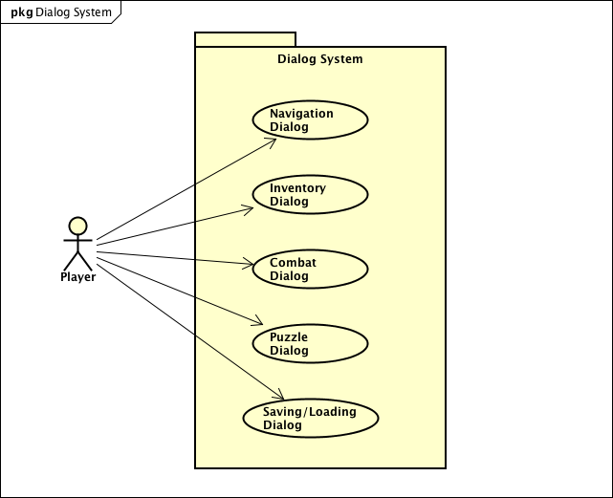

#### Purpose

The handle player input and direct it to the appropriate system for use.

#### Stimulus/Response Sequence

When the player enters input the system parses it and determines which system the player is attempting to use. Once the appropriate system has been determined the dialog system forwards the input to that system for the desired action to be executed. If the player’s input requires a response the dialog system will provide one.

#### Associated Functional Requirements

##### Functional Requirement 12

###### ID: FR12

###### Title: Player interaction

###### DESC: The dialog system is how the player will interact with the game. The player will enter input and the dialog system will decide which of the other systems should be used by parsing their input, and then directing the player’s input to that system.

###### DEP: None

### Feature 3: Navigation - Josh

### Use Case Diagram

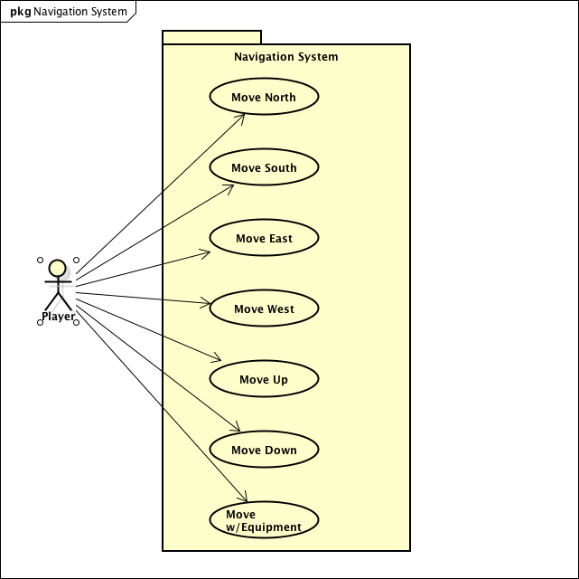

#### Purpose

The navigation system will allow the player to traverse around the game world. The system will be responsible for linking together rooms and controlling the player’s possible movement.

#### Stimulus/Response Sequence

When the player enters a room the navigation system will alert them to the possible exits from the room. When the player wishes to leave their current room they will enter a movement command and the navigation system will move the player to their desired destination.

#### Associated Functional Requirements

##### Functional Requirement 13

###### ID: FR13

###### Title: Player movement

###### DESC: The navigation system will control how the player is able to move about the game world. It will define the links that exist between rooms. These links will allow the player to move from one room to another. If a link does not exist, movement is not possible. The player will issue commands to move in a cardinal direction from their current room and if movement is possible in that direction the system will move the player to the room that is linked to that cardinal direction. Unlockable/hidden shortcuts between rooms will also exist in a limited number of rooms, and the player will access these by issuing a command to move up or down.

###### DEP: FR12

### Feature 4: Puzzle solving - Josh

#### Use Case Diagram

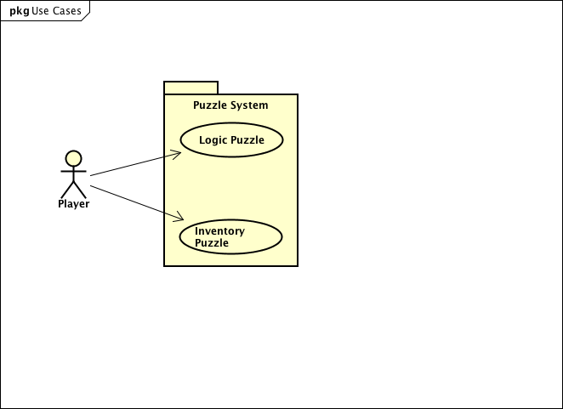

#### Purpose

To test the player’s logic/exploratory tendencies to progress with the game.

#### Stimulus/Response Sequence

The player will enter a room that contains a puzzle. Different puzzles will be solved in one of two major ways; logically or via the use of items from the player’s inventory. In the case of inventory puzzles, the player will be required to have in their possession an item that will have been found either in the puzzle room or in a room that was accessible previously. Logic puzzles may have hints to their solution observable in rooms previously accessible to the user.

#### Associated Functional Requirements

##### Functional Requirement 14

###### **ID: FR14**

###### Title: Logic Puzzles

###### DESC: The player will solve puzzles that require critical thinking. Hints to the solution may be placed around the parts of the map that were accessible previously to the puzzle room.

###### DEP: FR13

##### Functional Requirement 15

###### **ID: FR15**

###### Title: Inventory Puzzles

###### DESC: The player will solve puzzles that require the use of inventory items. Items will come from either rooms that were previously accessible to the player, or from defeated enemies.

###### DEP: FR12, FR18, FR19

### Feature 5: Saving/Loading - PAdeojo

#### Use Case Diagram

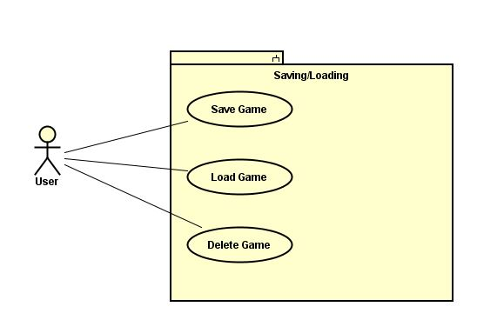

#### Purpose

To give the ability to leave the game and be able to save progress, so on return they can load where they left off.

#### Stimulus/Response Sequence

Saving

1. The player will type in save to initiate the saving process
2. The console will then ask the player to selct a number between 1-3, this will denote the save file
3. When they chooses a slot, a file will be created holding his data.

Loading

1. On startup the user will have the option to load a game.
2. There the game will ask for the user to chooses a load sloat from 1-3
3. Upon selection the file will be pulled from its location point and loaded.

#### Associated Functional Requirements

**ID:** FR16

DESC: This system will be in charge of allowing non-corrupted save files to be placed in a place reachable by the game system.

DEP: FR12

###### 

**ID:** FR17

DSEC: This will be in charge of pulling the information placed in the save file and loading back into the game as a playable file.

DEP: FR12, FR16

### Feature 6: Inventory/bag - Cristian*.*

#### Use Case Diagram

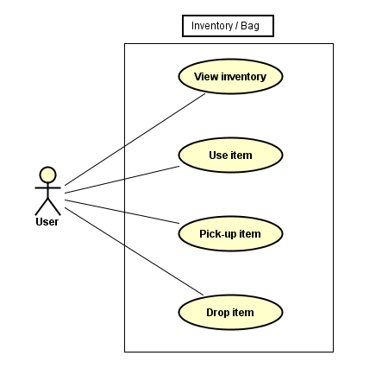

#### Purpose

Loading and viewing items in the inventory/bag which have been gathered throughout the course of the game which possibly serve a purpose.

#### Stimulus/Response Sequence There will be a button which loads up a list of items which have been collected. The list may be empty

#### View inventory lets the player see the items in the inventory/bag

* Use Item allows the player to make use of an item previously gathered to solve a puzzle or defeat an enemy.
* Pick-up lets the player pick up items in the room that he/she may use in the future.
* Drop allows the player to just get rid of an item that no longer is wanted or needed in the inventory.

#### Associated Functional Requirements

**ID:** FR18

Title: View Inventory.

DESC: The user will need to be engaged in a session of the game, in other words, the player needs to be playing the game.

DEP: The user needs to make use of the Main Menu to start a new game and the inventory bag will be empty or the player can load a previously saved session in which the inventory bag will have some items in it.

**ID:** FR19

Title: Use Item.

DESC: The player will be able to choose an item that has been previously added to the inventory, and then make use of this item.

DEP: The player would have to be playing a session of the game, and to use an item, the player must have previously picked up something to use.

**ID:** FR20

Title: Pick-up Item.

DESC: The player will be able to pick-up an item that is available during game play and therefore add it to the inventory. here is a vast variety of items available for the player to pick-up.

DEP: The player would have to be playing a session of the game, and an item that allows for pick-up must become available in order to be picked up.

**ID:** FR21

Title: Drop Item.

DESC: The player will be able to drop an item or eliminate it from the inventory.

DEP: In order for a player to drop an item, the item would need to be in the possession of the player and or in the inventory.

### Feature 7: Main Menu- Peter

### Use Case Diagram

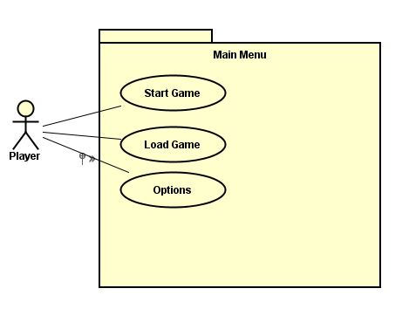

#### 

#### Purpose

To give guided options on startup of the application.

#### Stimulus/Response Sequence

The user will click on the application and this will let the game load up. Once the initial load up is finished the game will display the main menu.

#### Associated Functional Requirements

**ID:** FR22

Title: Load Game

DESC: This will be the first Screen that comes up after the initial load. Should be able to create a new game and load a saved game.

DEP: The load option is dependent that the save requirment works AND that the save feature is adequately saving the actual game.

**ID:** FR23

Title: New Game

DESC Should be able to create a new game.

DEP: FR12

**ID:** FR24

Title: Options

DESC Should be able to change size of font.

DEP: FR12

## Performance Requirements

The game should not crash, and it should load the next dialog box within half a second.

ID: QR1

TITLE: Load Speed

DESC: The game must start up within one second of opening it.

DEP: none

ID: QR2

TITLE: Response Speed

DESC: The game must respond to the user’s input within one second of them entering it.

DEP: none

## Design Constraints

ID: QR3

TITLE: Memory Usage

DESC: The game must use no more than 2MB of memory at any time.

DEP: none

## Software System Attributes

### Reliability

ID: QR4

TITLE: Reliability

DESC: The player must be able to complete the game without it crashing 100% of the time.

DEP: none

### Availability

ID: QR5

TITLE: Plays on demand

DESC: The game will play when the user clicks on it 100% of the time.

DEP: none

### Maintainability

ID: QR6

TITLE: Game adjustment

DESC: It should be easy for developers to access the necessary stats of rooms, enemies, and items to adjust them without needing to change the game’s code should it be needed for game balance or other reasons.

DEP: none

## Logical Database Requirements

ID: QR7

TITLE: Save Data

DESC: The user must be able to place their save data into a database and retrieve it later. A text file may be used instead of a database.

DEP: none

ID: QR8

TITLE: Game Data

DESC: Most elements of game data, including information about the rooms, enemies, and items, should be placed in a database or text file.

DEP: none